Qno1: SELECT first_name, last_name, salary * 12 AS yearly_salary FROM employees;
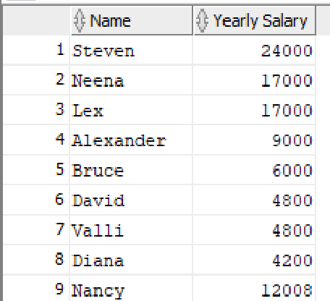
Qno2: SELECT * FROM employees WHERE (salary * 1.10) > 5000;
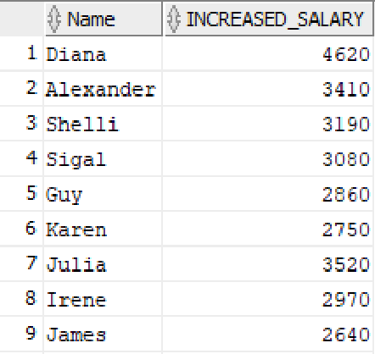
Qno3: SELECT first_name, last_name, (salary + NVL(commission, 0)) AS total_earnings FROM employees;
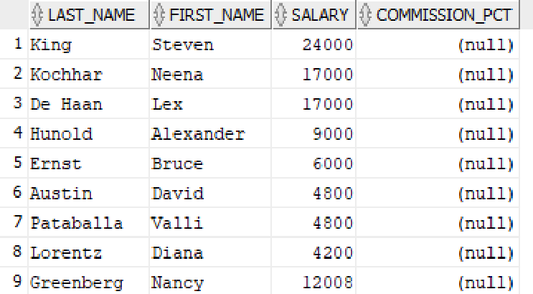

Qno4: SELECT first_name || ' ' || last_name AS full_name FROM employees;
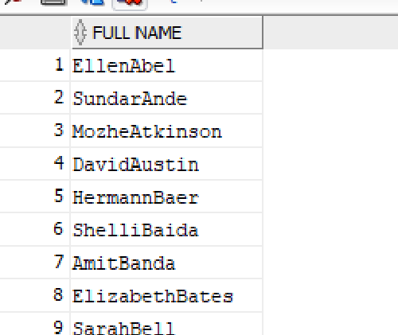
Qno5: SELECT * FROM employees WHERE UPPER(first_name) LIKE 'A%' OR UPPER(first_name) LIKE 'J%';
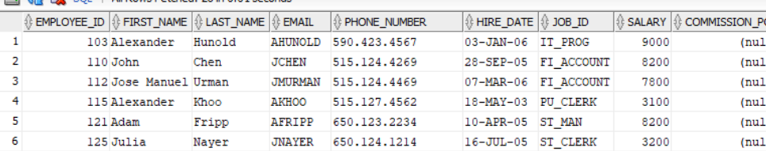
Qno6: SELECT * FROM employees WHERE LOWER(last_name) LIKE '%son%';

Qno7: SELECT * FROM employees WHERE (salary * 12) - NVL(commission, 0) > 50000;

Qno8: SELECT * FROM employees WHERE (hire_date + 30) < SYSDATE;
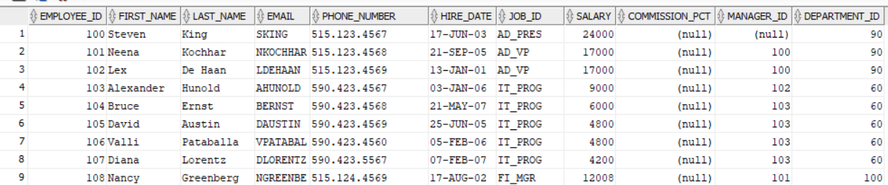
Qno9: SELECT * FROM employees WHERE (salary / 12) BETWEEN 300 AND 700;
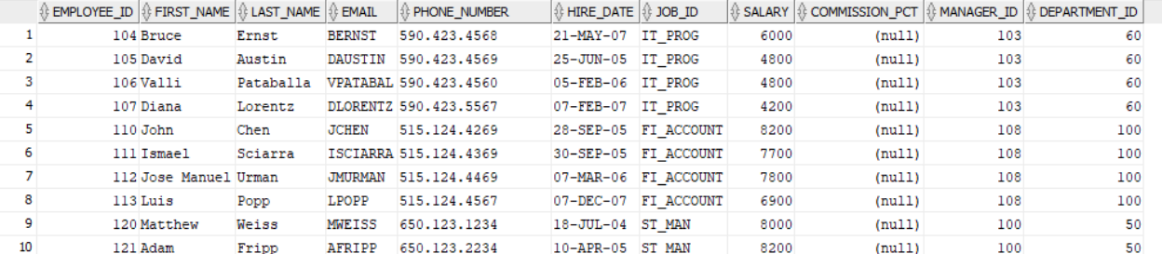
Qno10: SELECT * FROM employees WHERE department_id IN (10, 20, 30);

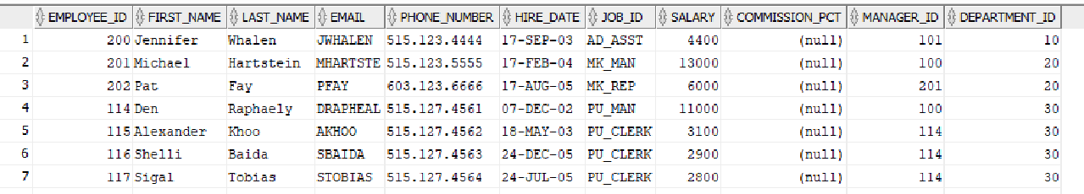

Qno11: SELECT DISTINCT job_id FROM employees;
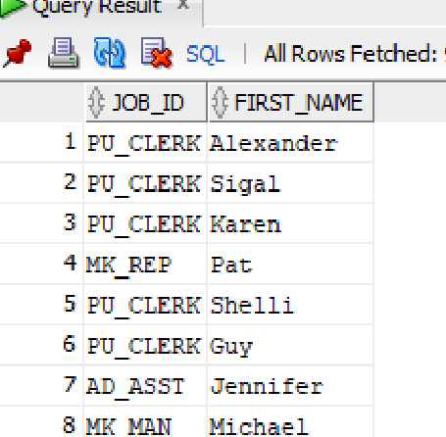
Qno12: SELECT * FROM employees ORDER BY last_name ASC, salary DESC;
Qno13: SELECT * FROM employees WHERE LENGTH(first_name) > 5;


Qno14: SELECT * FROM employees WHERE MOD(salary, 1000) = 0;

Qno15: SELECT * FROM employees WHERE commission IS NULL OR commission = 0;

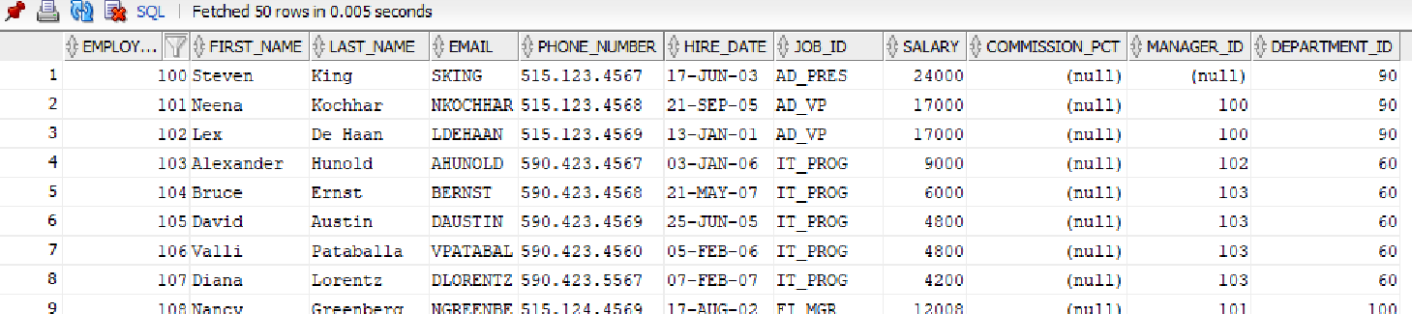
Qno16: SELECT * FROM employees WHERE TO_CHAR(hire_date, 'MM') = '01';
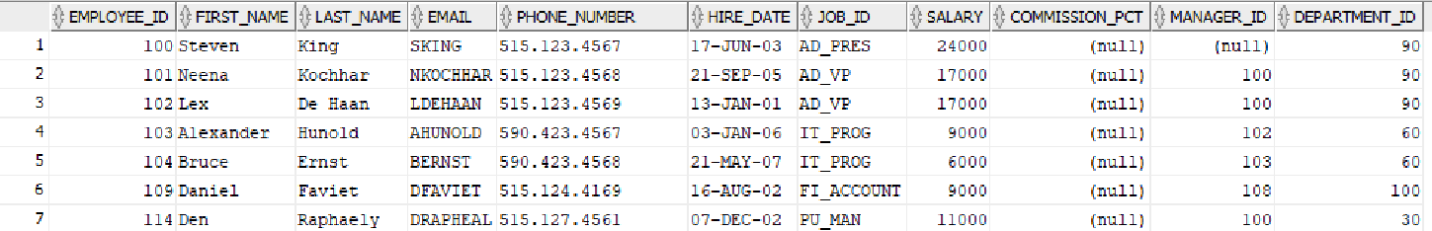
Qno17: SELECT * FROM employees WHERE first_name LIKE 'El%' AND last_name LIKE '%o';
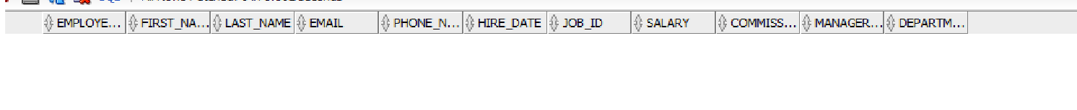
Qno18: SELECT * FROM employees WHERE salary > 4000 AND salary < 7000;
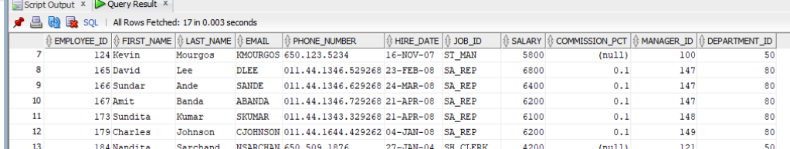

Qno19: SELECT * FROM employees WHERE (salary + NVL(commission, 0)) > 6000 OR hire_date > TO_DATE('2010-01-01', 'YYYY-MM-DD');

Qno20: SELECT UPPER(first_name), LOWER(last_name) FROM employees;

Qno21: SELECT * FROM employees WHERE TRUNC(hire_date) < TO_DATE('2020-01-01', 'YYYY-MM-DD');
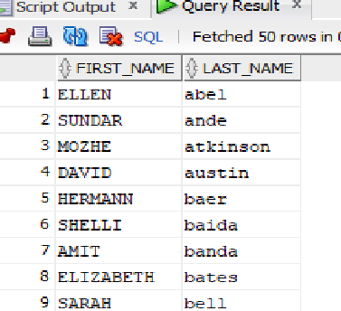
Qno22: SELECT SUBSTR(last_name, 1, 3) FROM employees;
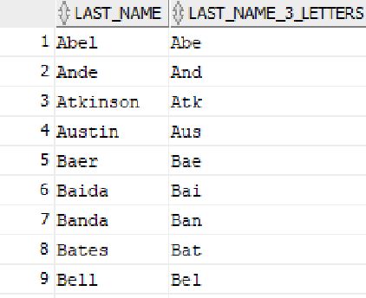
Qno23: SELECT first_name, ROUND(salary, -2) FROM employees;
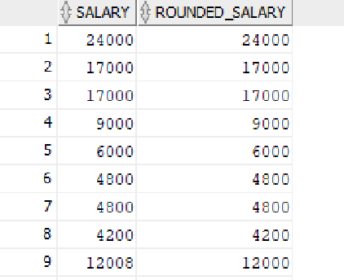
Qno24: SELECT * FROM employees WHERE salary > 5000 AND department_id <> 90;
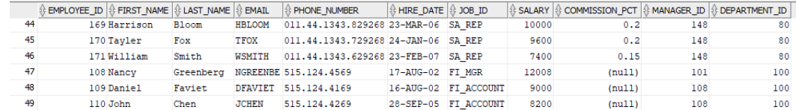
Qno25: SELECT hire_date, (SYSDATE - hire_date) AS days_since_hired, (hire_date + 10) AS hire_plus_ten FROM employees;
